WEEK 1 TASK: DATA ACQUISITION, CLEANING, AND EXPLORATORY DATA ANALYSIS

Indian E-Commerce Sales Analytics Dataset
- Internship: Yuva Intern – Virtual Data Science with Python Apprentice Intern
- Source: Kaggle
- Tools: Python, Jupyter Notebook, Pandas, Matplotlib, Seaborn

1. INTRODUCTION

1.1 Task Objective
The objective of this Week 1 task is to simulate the data preparation process required in a real-world data science project. The task focuses on acquiring a publicly available dataset, understanding its structure, identifying data quality issues, cleaning and preprocessing the data, and performing Exploratory Data Analysis (EDA) using Python.
The project uses an Indian E-Commerce Sales Analytics Dataset containing customer, product, and sales transaction information. The analysis demonstrates how raw data can be transformed into a structured and analysis-ready dataset.

1.2 Project Objectives
The major objectives of the project are:
- To acquire and load a publicly available dataset from the internet.
- To understand the structure and characteristics of the dataset.
- To identify missing values and assess their significance.
- To detect duplicate records and invalid data.
- To correct inappropriate data types using Pandas.
- To clean and preprocess the data using Python.
- To perform Exploratory Data Analysis using statistical methods.
- To create meaningful visualizations using Matplotlib and Seaborn.
- To identify important patterns and business insights from the cleaned dataset.
- To document the complete data preparation and analysis process.

2. DATA ACQUISITION

2.1 Dataset Overview
The dataset selected for this project is the Indian E-Commerce Sales Analytics Dataset, obtained from Kaggle.
The dataset represents a realistic e-commerce environment and contains information related to customers, products, and sales transactions.

Field | Details
Dataset Name | Indian E-Commerce Sales Analytics Dataset
Source | Kaggle
Domain | E-Commerce / Business Analytics
Number of Tables | 3
Customer Records | 40,000
Product Records | 2,000
Sales Records | 250,000
Total Records | 292,000
Format | CSV
Programming Language | Python
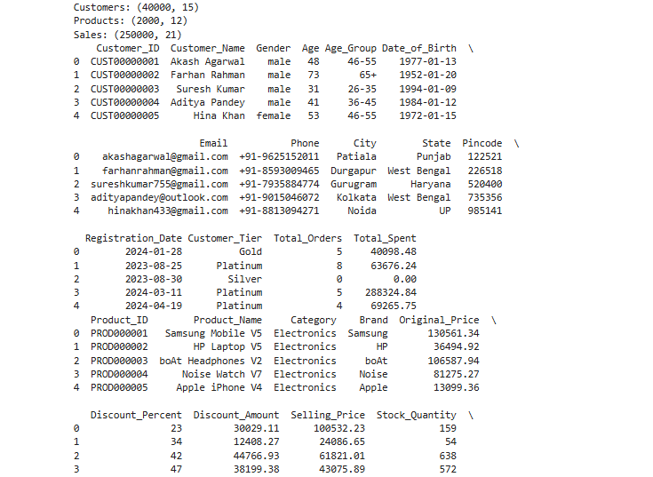
The dataset therefore contains 292,000 records across three related CSV tables.

2.2 Why This Dataset?
This dataset was selected because it represents a realistic e-commerce business scenario and provides multiple related tables that can be analyzed using Python.
The dataset is suitable for practicing:
- Data acquisition
- Data inspection
- Data cleaning
- Missing-value analysis
- Duplicate detection
- Data type correction
- Anomaly detection
- Exploratory Data Analysis
- Data visualization
- Business insight generation
The relational structure of the dataset is also useful because customer, product, and transaction information can be connected through common identifiers. This makes the dataset appropriate for both data science and business analytics applications.

2.3 Files Downloaded
Three CSV files were used in this project.
File | Rows | Main Information
customers.csv | 40,000 | Customer details, demographics, location, customer tier and spending
products.csv | 2,000 | Product details, categories, brands, pricing, ratings and stock
sales.csv | 250,000 | Orders, customers, products, dates, payments and order status

customers.csv
Contains 40,000 customer records and 15 columns.
Important fields include:
- Customer_ID
- Customer_Name
- Gender
- Age
- Age_Group
- Date_of_Birth
- City
- State
- Registration_Date
- Customer_Tier
- Total_Orders
- Total_Spent

products.csv
Contains 2,000 product records and 12 columns.
Important fields include:
- Product_ID
- Product_Name
- Category
- Brand
- Original_Price
- Discount_Percent
- Discount_Amount
- Selling_Price
- Stock_Quantity
- Weight_kg
- Avg_Rating
- Total_Reviews

sales.csv
Contains 250,000 sales records and 21 columns before cleaning.
Important fields include:
- Order_ID
- Customer_ID
- Product_ID
- Order_Date
- Order_Time
- Delivery_Date
- Quantity
- Unit_Price
- Order_Value
- Shipping_Cost
- Coupon_Code
- Coupon_Discount
- Total_Amount
- Payment_Mode
- Order_Status
- Rating
- Review_Text
- City
- State
- Customer_Age
- Customer_Age_Group

2.4 Dataset Relationships
The three tables are related through common identifier columns.
customers.csv
|
| Customer_ID
↓
sales.csv
|
| Product_ID
↓
products.csv
The Customer_ID field connects customers with their sales transactions, while the Product_ID field connects sales transactions with the product catalog.
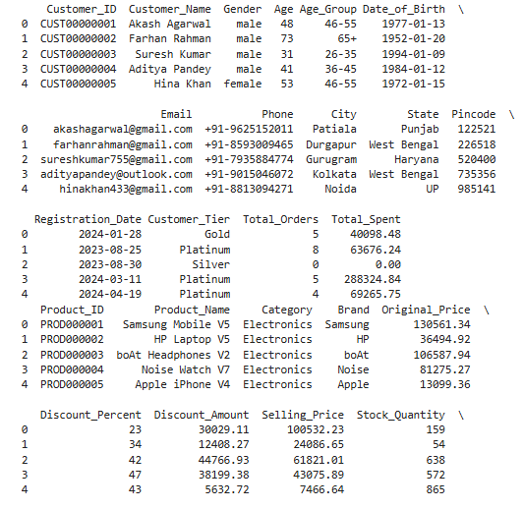
This relationship allows customer, product, and sales information to be analyzed together in future analysis.

2.5 Loading the Data
The dataset was loaded into Python using the Pandas library.
import pandas as pd

# Load all three tables
customers = pd.read_csv("customers.csv")
products = pd.read_csv("products.csv")
sales = pd.read_csv("sales.csv")

# Basic shape check
print("Customers:", customers.shape)
print("Products:", products.shape)
print("Sales:", sales.shape)

# Preview each table
print(customers.head())
print(products.head())
print(sales.head())

# Check column names and data types
print(customers.info())
print(products.info())
print(sales.info())

# Summary statistics
print(customers.describe())
print(products.describe())
print(sales.describe())
The initial shape check produced:
Customers: (40000, 15)
Products: (2000, 12)
Sales: (250000, 21)
The initial inspection also showed that the sales table contained missing values and that several date-related columns were stored as object data types.

3. DATA UNDERSTANDING

3.1 Dataset Shape
The initial dimensions of the three tables were:
Table | Rows | Columns
Customers | 40,000 | 15
Products | 2,000 | 12
Sales | 250,000 | 21
The sales table is the largest table and contains transaction-level information required for analyzing revenue, order status, payment methods, and time-based trends.
The customer table provides demographic and customer-level information, while the product table provides product and pricing information.

3.2 Column Information

Customers Table
The customer table contains information related to customer identity, demographics, location, registration details, customer tier, and spending behavior.
Important columns include:
Column | Description
Customer_ID | Unique identifier for each customer
Customer_Name | Customer name
Gender | Customer gender
Age | Customer age
Age_Group | Customer age category
Date_of_Birth | Customer date of birth
City | Customer city
State | Customer state
Registration_Date | Date of customer registration
Customer_Tier | Customer membership tier
Total_Orders | Number of orders placed
Total_Spent | Total amount spent

Products Table
The product table contains product, pricing, stock, and rating information.
Important columns include:
Column | Description
Product_ID | Unique product identifier
Product_Name | Product name
Category | Product category
Brand | Product brand
Original_Price | Original product price
Discount_Percent | Discount percentage
Discount_Amount | Discount amount
Selling_Price | Final selling price
Stock_Quantity | Available stock
Weight_kg | Product weight
Avg_Rating | Average product rating
Total_Reviews | Number of product reviews

Sales Table
The sales table contains order-level information.
Important columns include:
Column | Description
Order_ID | Unique order identifier
Customer_ID | Customer associated with the order
Product_ID | Product associated with the order
Order_Date | Date of order
Order_Time | Time of order
Delivery_Date | Delivery date
Quantity | Quantity purchased
Unit_Price | Price per unit
Order_Value | Total order value before additional adjustments
Shipping_Cost | Shipping cost
Coupon_Code | Coupon applied to the order
Coupon_Discount | Discount from coupon
Total_Amount | Final transaction amount
Payment_Mode | Payment method
Order_Status | Current status of the order
Rating | Customer rating
Review_Text | Customer review
State | Customer/order state
Customer_Age | Age of customer
Customer_Age_Group | Customer age category

3.3 Missing Value Analysis
Missing values were examined in all three tables.
The customers.csv and products.csv tables contained no missing values in their columns.
The sales.csv table contained missing values in three important fields.
Column | Non-Null Count | Missing Count | Approx. Missing %
Coupon_Code | 50,185 | 199,815 | 80%
Rating | 120,030 | 129,970 | 52%
Review_Text | 120,030 | 129,970 | 52%
The missing values were analyzed according to their business meaning rather than being removed without investigation.
Coupon_Code was handled by replacing missing values with "No Coupon".Rating and Review_Text were retained as missing because an absent review indicates that the customer did not provide review information.

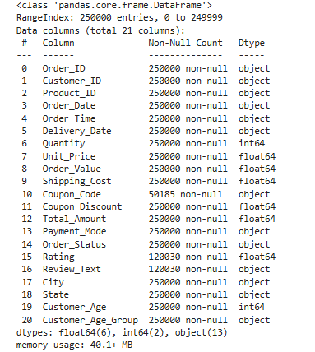

3.4 Data Type Analysis
The initial data inspection showed that several date and time columns were stored as strings.
Table | Column | Initial Type | Required Type
Customers | Date_of_Birth | object | datetime
Customers | Registration_Date | object | datetime
Sales | Order_Date | object | datetime
Sales | Delivery_Date | object | datetime
Sales | Order_Time | object | time
These data type issues had to be corrected before performing time-based analysis.

3.5 Anomaly Detection
A statistical summary of the sales table revealed an invalid value in the Total_Amount column.
Minimum Total_Amount = -21.56
A negative transaction amount is not valid for the analysis of sales revenue. Therefore, the records containing negative Total_Amount values were identified and removed during the cleaning stage.

4. DATA CLEANING

4.1 Handling Missing Values
Missing values were handled according to the meaning of each column.

Coupon Code
The Coupon_Code column had approximately 80% missing values.
Instead of removing these rows, the missing values were replaced with "No Coupon" because most orders simply did not use a coupon.
sales['Coupon_Code'].fillna('No Coupon', inplace=True)
This approach keeps all transaction records while converting missing coupon information into a meaningful category.

Rating and Review Text
The Rating and Review_Text columns had approximately 52% missing values.
These values were not replaced with artificial values because missing review information is expected when a customer has not provided a review.
Instead, a new indicator variable was created to identify reviewed orders.

4.2 Creating Has_Review
A new column named Has_Review was created using the Rating column.
sales['Has_Review'] = sales['Rating'].notna().astype(int)
The column represents:
1 → Customer rating is available
0 → Customer rating is not available
This feature makes it possible to distinguish between reviewed and non-reviewed orders during future analysis.

4.3 Removing Duplicates
Duplicate rows were checked in all three datasets.
print("Duplicates in customers:", customers.duplicated().sum())
print("Duplicates in products:", products.duplicated().sum())
print("Duplicates in sales:", sales.duplicated().sum())
The result was:
Duplicates in customers: 0
Duplicates in products: 0
Duplicates in sales: 0
Therefore, no duplicate records were found.
The standard duplicate-removal commands were also applied:
customers.drop_duplicates(inplace=True)
products.drop_duplicates(inplace=True)
sales.drop_duplicates(inplace=True)
Since the duplicate count was zero in all tables, the number of records remained unchanged.

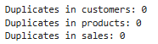

4.4 Correcting Data Types
The date and time columns were converted into appropriate formats using Pandas.
customers['Date_of_Birth'] = pd.to_datetime(
customers['Date_of_Birth']
)

customers['Registration_Date'] = pd.to_datetime(
customers['Registration_Date']
)

sales['Order_Date'] = pd.to_datetime(
sales['Order_Date']
)

sales['Delivery_Date'] = pd.to_datetime(
sales['Delivery_Date']
)

sales['Order_Time'] = pd.to_datetime(
sales['Order_Time'],
format='%H:%M:%S'
).dt.time
After conversion:
- Order_Date became datetime64[ns]
- Delivery_Date became datetime64[ns]
- Order_Time was converted into a time value
- Customer date columns were converted into datetime values
This correction was necessary for reliable time-based analysis.

4.5 Removing Invalid Transactions
The Total_Amount column contained five negative transactions.
The invalid records were identified and removed using:
invalid = sales[sales['Total_Amount'] < 0]

print(
f"Invalid negative Total_Amount rows: {len(invalid)}"
)

sales = sales[sales['Total_Amount'] >= 0]
Output:
Invalid negative Total_Amount rows: 5
Therefore, five invalid records were removed.

4.6 Cleaning Verification
After all cleaning operations were completed, the dataset dimensions were:
Customers shape: (40000, 15)
Products shape: (2000, 12)
Sales shape: (249995, 22)
The sales table contains 22 columns after adding the Has_Review feature.
The final null-value check showed that only the review-related fields remained missing:
Rating 129969
Review_Text 129969
All other fields contained zero missing values.
The final sales data types also confirmed that the date columns were successfully converted.

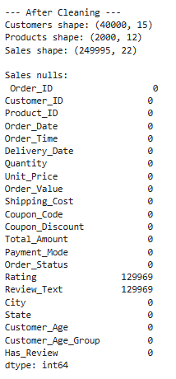

4.7 Cleaning Summary
Check | Result
Duplicate customers | 0
Duplicate products | 0
Duplicate sales | 0
Invalid negative transactions | 5 removed
Initial sales records | 250,000
Final sales records | 249,995
Coupon missing values | Replaced with No Coupon
Review missing values | Retained and identified using Has_Review
Date columns | Converted to appropriate date/time types
New feature | Has_Review created
The cleaning process successfully transformed the raw sales data into a structured and analysis-ready dataset.

5. EXPLORATORY DATA ANALYSIS
Exploratory Data Analysis was performed on the cleaned data to identify trends, patterns, distributions, and important business observations.
Five visualizations were created using Matplotlib and Seaborn.

5.1 Order Status Distribution

Visualization
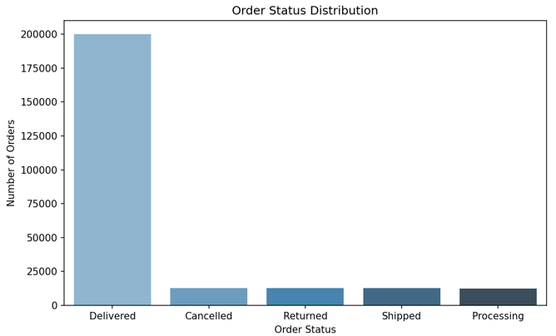Figure 1: Order Status Distribution

Code
import matplotlib.pyplot as plt
import seaborn as sns

plt.figure(figsize=(8, 5))

order_counts = sales['Order_Status'].value_counts()

sns.barplot(
x=order_counts.index,
y=order_counts.values,
hue=order_counts.index,
palette='Blues_d',
legend=False
)

plt.title('Order Status Distribution')
plt.xlabel('Order Status')
plt.ylabel('Number of Orders')

plt.tight_layout()
plt.savefig('viz1_order_status.png', dpi=150)
plt.show()

Observation
After cleaning, the dataset contained 249,995 sales orders.
The order-status distribution was:
Order Status | Number of Orders
Delivered | 200,135
Cancelled | 12,506
Returned | 12,493
Shipped | 12,459
Processing | 12,402
Delivered orders represented approximately 80.1% of the total cleaned orders.

Insight
The high proportion of delivered orders indicates a strong fulfillment rate in the dataset. Among the remaining transactions, cancelled, returned, shipped, and processing orders are distributed relatively evenly.
This suggests that there is no single non-delivered order status dominating the dataset.

5.2 Top 10 States by Total Revenue

Visualization
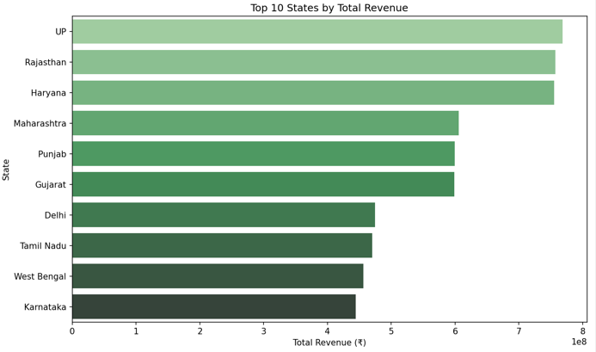Figure 2: Top 10 States by Total Revenue

Code
plt.figure(figsize=(10, 6))

state_revenue = (
sales.groupby('State')['Total_Amount']
.sum()
.sort_values(ascending=False)
.head(10)
)

sns.barplot(
x=state_revenue.values,
y=state_revenue.index,
hue=state_revenue.index,
palette='Greens_d',
legend=False
)

plt.title('Top 10 States by Total Revenue')
plt.xlabel('Total Revenue (₹)')
plt.ylabel('State')

plt.tight_layout()
plt.savefig('viz2_state_revenue.png', dpi=150)
plt.show()

Observation
The top five states by total revenue were:
Rank | State | Approximate Revenue
1 | UP | ₹768.35 million
2 | Rajasthan | ₹757.29 million
3 | Haryana | ₹755.22 million
4 | Maharashtra | ₹605.83 million
5 | Punjab | ₹599.23 million

Insight
UP generated the highest total revenue among the states in the dataset, followed by Rajasthan and Haryana.
These states represent important revenue-generating markets and could be considered for future regional marketing, customer acquisition, and logistics analysis.

5.3 Monthly Revenue Trend

Visualization
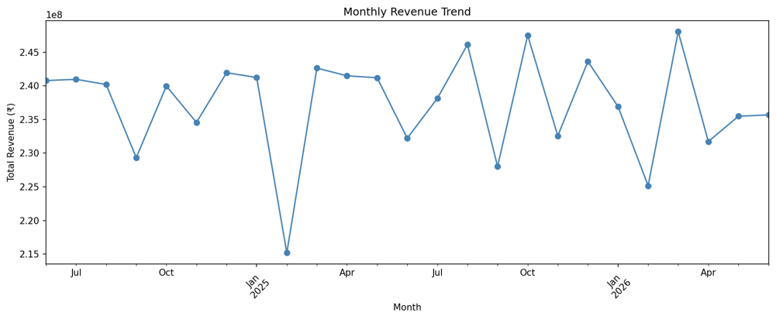Figure 3: Monthly Revenue Trend

Code
plt.figure(figsize=(12, 5))

sales['Month'] = sales['Order_Date'].dt.to_period('M')

monthly_revenue = (
sales.groupby('Month')['Total_Amount']
.sum()
)

monthly_revenue.plot(
kind='line',
marker='o',
color='steelblue'
)

plt.title('Monthly Revenue Trend')
plt.xlabel('Month')
plt.ylabel('Total Revenue (₹)')
plt.xticks(rotation=45)

plt.tight_layout()
plt.savefig('viz3_monthly_revenue.png', dpi=150)
plt.show()

Observation
The highest monthly revenue was recorded in:
March 2026 — ₹248,032,785.65
The lowest monthly revenue was recorded in:
February 2025 — ₹215,193,135.50

Insight
The monthly revenue trend shows noticeable variation over the observed period.
March 2026 recorded the highest monthly revenue, while February 2025 recorded the lowest. This variation can be investigated further in future analysis to determine whether seasonal demand, promotions, customer behavior, or other factors contributed to the changes.

5.4 Payment Mode Distribution

Visualization
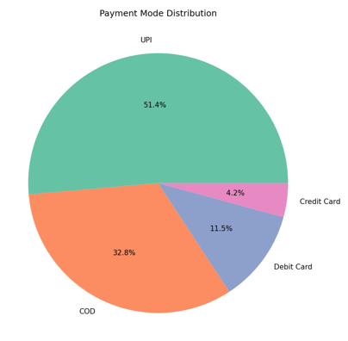
Figure 4: Payment Mode Distribution

Code
plt.figure(figsize=(7, 7))

payment_counts = sales['Payment_Mode'].value_counts()

plt.pie(
payment_counts.values,
labels=payment_counts.index,
autopct='%1.1f%%',
colors=sns.color_palette('Set2')
)

plt.title('Payment Mode Distribution')

plt.tight_layout()
plt.savefig('viz4_payment_mode.png', dpi=150)
plt.show()

Observation
The payment methods were distributed as follows:
Payment Mode | Transactions | Approximate Share
UPI | 128,471 | 51.4%
COD | 82,091 | 32.8%
Debit Card | 28,856 | 11.5%
Credit Card | 10,577 | 4.2%
UPI was the most commonly used payment method in the dataset.

Insight
UPI accounted for more than half of the transactions, making it the dominant payment method.
COD was the second most common payment option, showing that both digital and cash-based payment methods remain significant within the dataset.
This information can be useful when designing payment-related customer experiences for an e-commerce platform.

5.5 Customer Age Distribution

Visualization
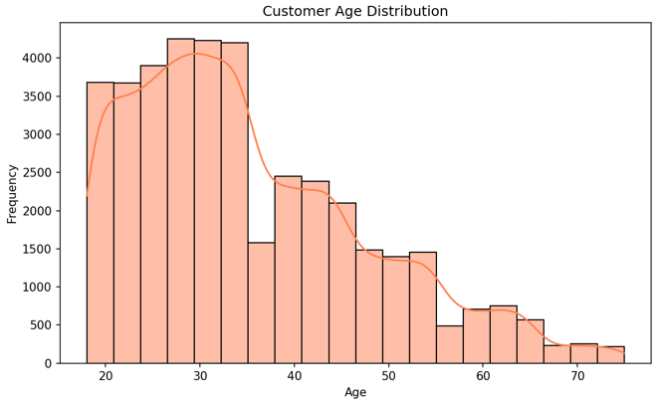
Figure 5: Customer Age Distribution

Code
plt.figure(figsize=(8, 5))

sns.histplot(
customers['Age'],
bins=20,
kde=True,
color='coral'
)

plt.title('Customer Age Distribution')
plt.xlabel('Age')
plt.ylabel('Frequency')

plt.tight_layout()
plt.savefig('viz5_age_distribution.png', dpi=150)
plt.show()

Observation
The customer age statistics were:
Statistic | Value
Minimum Age | 18
Maximum Age | 75
Mean Age | 35.3 years
Most Common Age Group | 26–35

Insight
The 26–35 age group is the most common customer segment in the dataset.
The average customer age of 35.3 years indicates that the dataset contains a large proportion of young and middle-aged customers.
Further analysis could examine whether customer age is related to purchasing frequency, total spending, preferred payment method, or product category.

6. SUMMARY OF KEY INSIGHTS
The Exploratory Data Analysis produced the following major findings:

1. Strong Order Fulfillment
Approximately 80.1% of the cleaned orders were delivered, representing 200,135 delivered orders out of 249,995 sales records.

2. Leading Revenue-Generating States
UP, Rajasthan, and Haryana were the top three states by total revenue. UP recorded the highest total revenue in the dataset.

3. Monthly Revenue Variation
Monthly revenue varied across the observed period. March 2026 recorded the highest revenue of ₹248.03 million, while February 2025 recorded the lowest revenue of ₹215.19 million.

4. UPI as the Dominant Payment Method
UPI was the most widely used payment method, accounting for approximately 51.4% of transactions.

5. Core Customer Age Group
The average customer age was 35.3 years, and the 26–35 age group was the most common customer segment.

Overall Business Interpretation
The EDA suggests that the e-commerce platform represented by the dataset has a strong delivery rate, concentrated revenue contribution from several states, significant adoption of digital payment methods, and a customer base strongly represented by young adults.
These findings provide a useful foundation for deeper business and predictive analysis.

7. CONCLUSION
This Week 1 project successfully demonstrated the essential stages of a data science data-preparation workflow, including data acquisition, data understanding, data cleaning, preprocessing, and Exploratory Data Analysis.
The Indian E-Commerce Sales Analytics Dataset was acquired from Kaggle and loaded into Python using Pandas. The three tables — customers, products, and sales — were inspected to understand their structure and relationships.
During the cleaning process, missing values were analyzed according to their business meaning. Missing coupon values were replaced with "No Coupon", while missing rating and review values were retained because they represent orders without customer feedback. A new Has_Review feature was created to identify reviewed and non-reviewed orders.
Duplicate checks showed zero duplicate rows across all three tables. Date and time fields were converted into appropriate data types to support time-based analysis. Five invalid sales records containing negative Total_Amount values were identified and removed. As a result, the sales table was reduced from 250,000 to 249,995 valid records.
Five visualizations were created to analyze order status, state-wise revenue, monthly revenue, payment modes, and customer age distribution. The analysis revealed an approximately 80.1% delivery rate, strong revenue contributions from states such as UP, Rajasthan, and Haryana, UPI as the dominant payment method, and a strong representation of customers in the 26–35 age group.
Overall, this project provided practical experience in transforming raw e-commerce data into a clean, structured, and analysis-ready dataset and demonstrated how exploratory analysis can be used to generate meaningful business insights.

8. FUTURE ANALYSIS
The cleaned dataset provides opportunities for several additional analyses in future stages. These are proposed areas for further investigation and are not part of the Week 1 implementation.

8.1 Customer Lifetime Value
Customer purchasing history can be analyzed to estimate Customer Lifetime Value (CLV) and identify high-value customers.

8.2 Product Performance
Products and categories can be compared using sales volume, revenue, ratings, discounts, and stock information to identify high-performing and under-performing products.

8.3 Coupon Effectiveness
The relationship between coupons, discounts, order value, and purchasing frequency can be studied to understand the effectiveness of promotional campaigns.

8.4 Return and Cancellation Analysis
Returned and cancelled transactions can be analyzed by state, product category, payment method, and customer segment to identify possible causes and operational patterns.

8.5 Customer Segmentation and Churn Analysis
Customers can be segmented using age, spending, order frequency, customer tier, and other behavioral attributes. This can provide a foundation for identifying inactive customers and developing future churn-prediction models.

